**Banking and ATM network using CCNA**

**Industrial Training Project Report**

Bachelor of Technology

in

**Information Technology**

By:

**Prajneet Singh Ruprai**

**Session: 2017-2021**



**Department of Information Technology**

**Guru Tegh Bahadur Institute of Technology**

**Guru Gobind Singh Indraprastha University**

**Dwarka, New Delhi**

**Year 2019-2020**

**Contents**

**S.no. Title Pg. No.**

**Title Page**

**Contents**

1. **Introduction** 1

2. **Network**  2

* 1. LAN 2
  2. MAN 3

2.3 WAN 3

3. **Hub** 5

* 1. Types of Hubs 5

3.1.1 Active Hub 5

3.1.2 Passive Hub 5

4.  **Routing**  7

4.1 What is a router? 7

4.2 Features of router 7

4.3 Types of Routers 8

4.4 Router Components 9

4.5 External Connections 9

4.6 Router Connections 10

4.7 Cisco 3600 series router 10

4.8 Router ports/interfaces 11

4.9 Router modes 12

4.10 Initial Configuration 12

4.10.1 Some basic commands 12

4.10.2 Change the router name 13

4.10.3 Set Router password 13

4.10.4 Set console password 13

4.10.5 Set VTY password 14

4.11 Interface Configuration 14

4.12 IP configuration 15

4.13 Starting a router 15

5.  **Switching**  17

5.1 Configuration options 17

5.2 Show cisco switch commands 19

5.3 Cisco switch configuration commands 20

6.  **Requirements for Project**  22

7. **IP Addressing** 24

7.1 Address classes 24

7.2 Subnetting 24

7.3 Subnet masking 24

7.4 DHCP 25

8. **Routing Protocols** 26

8.1 Types of routing 26

8.1.1 Static routing algorithms 26

8.1.2 Dynamic routing algorithms 27

9. **VLAN**  29

9.1 Simplification of end station moves,adds and changes 29

9.2 Controlled traffic activity 29

9.3 Work group and network security 29

10. **Network Address Translation(NAT)** 31

11. **Appendix I**  32

12. **Appendix II**  41

13. **Conclusion** 50

14. **Future Scope** 51

15. **References** 52

1. **Introduction**

The following case study is used to illustrate the process and documentation required for a network design. This case study presents a scenario in which the Banks & ATM has hired a Network Consultant Group to design their network. In order to help organization this project, the scenario has been broken into eight phases listing requirements for each phase. A worksheet is to be completed for each part. A formal report, similar to what would be given to the banks, will need to be created after all tasks have been completed.

This case study requires that you accomplish the following:

1. Use the resources provided, diagram and narrative, to set up the physical network.

2. Set up an IP subnetting scheme

3. Configure the routers as required.

4. Set up and configure the switches and VLANS as required.

5. Verify and troubleshoot all connections.

6. Provide detailed documentation in the appropriate format.

7. Provide a written final report

1. **Network**

A network consists of two or more computers that are linked in order to share resources (such as printers and CD-ROMs), exchange files, or allow electronic communications. The computers on a network may be linked through cables, telephone lines, radio waves, satellites, or infrared light beams.

The three basic types of networks include:

* Local Area Network (LAN)
* Metropolitan Area Network (MAN)
* Wide Area Network (WAN)

**2.1 LAN (Local Area Network)**

A Local Area Network (LAN) is a network that is confined to a relatively small area. It is generally limited to a geographic area such as a writing lab, school, or building. Rarely are LAN computers more than a mile apart.



(Figure 2.1- LAN Network)

In a typical LAN configuration, one computer is designated as the file server. It stores all of the software that controls the network, as well as the software that can be shared by the computers attached to the network. Computers connected to the file server are called workstations. The workstations can be less powerful than the file server, and they may have additional software on their hard drives. On most LANs, cables are used to connect the network interface cards in each computer. See the Topology, Cabling, and Hardware sections of this tutorial for more information on the configuration of a LAN.

**2.2 MAN (Metropolitan Area Network)**

A Metropolitan Area Network (MAN) covers larger geographic areas, such as cities or school districts. By interconnecting smaller networks within a large geographic area, information is easily disseminated throughout the network. Local libraries and government agencies often use a MAN to connect to citizens and private industries.



(Figure 2.2- Man Network)

One example of a MAN is the MIND Network located in Pasco County, Florida. It connects all of Pasco's media centers to a centralized mainframe at the district office by using dedicated phone lines, coaxial cabling, and wireless communications.

**2.3 WAN (Wide Area Network)**

Wide Area Networks (WANs) connect larger geographic areas, such as Florida, the United States, or the world. Dedicated transoceanic cabling or satellite uplinks may be used to connect this type of network.

(Figure 2.3- WAN Network)

Using a WAN, schools in Florida can communicate with places like Tokyo in a matter of minutes, without paying enormous phone bills. A WAN is complicated. It uses multiplexers to connect local and metropolitan networks to global communications networks like the Internet. To users, however, a WAN will not appear to be much different than a LAN or a MAN.

1. **Hub**

In data communication, a hub is the pivot of convergence where data arrives from one or more directions and is forwarded out in more or more directions. A hub usually includes a switch (in telecommunication, a switch is a network device that selects a path or circuit for sending a unit of data to its next destination) of some kind. The distinction seems to be that the hub is the point where data comes together and the switch is what determines how and where data is forwarded from the place where data comes together. A hub is a hardware that acts as a central connecting point and joins lines in a star network configuration.

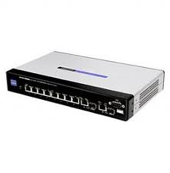

(Figure 3.1- Hub)

**3.1 Types of Hubs**

As you may have already guessed, hubs perform a crucial function on networks with a star topology. There are many different types of hubs, each offering specific features that allow you to provide varying levels of service.

* 1. ACTIVE
  2. PASSIVE

**3.1.1 Active Hub**

Active hubs actually do something other than simply rebroadcast data. Generally, that have all of the features of passive hubs, with the added bonus of actually watching the data sent out. Active hubs take a larger role in Ethernet communication by implementing a technology called store and forward where the hubs actually look at the data they are transmitting before sending it. This is not to say that the hub

prioritizes certain packets of data. It does, however, repair certain “damaged” packets and will retime the distribution of other packets.

It a signal received by an active hub is weak but still readable, the active hub restores the signal to a stronger state before rebroadcast it. This feature allows certain devices that are not operating within optimal parameters to still be used on your network. If a device is not broadcasting a signal strong enough to be seen by other devices on a network that uses passive hubs, the signal amplification provided by an active hub may allow that device to continue to function on you LAN. Additionally, some active hubs will report devices on your networks that are not fully functional. In this way, active hubs also provide certain diagnostic capabilities for your network.

Active hubs will also re-time and re-synchronize certain packets when they are being transmitted. Certain cable runs may experience electromagnetic (EM) disturbances that prevent packets from reaching the hub or the device at the end o the cable run in timely fashion. In other situations, the packets may not reach the destination at all.

**3.1.2 Passive Hub**

Passive hubs, as the name suggests, are rather quiescent creatures. They do not do very much to enhance the performance of your LAN, nor do they do anything to assist you in troubleshooting faulty hardware or finding performance bottlenecks. They simply take all of the packets they receive on a single port and rebroadcast them across all ports-the simplest thing that a hub can do. Passive hubs commonly have one 10base-2 port in addition to RJ-45 connectors that connect each LAN device.

As you have already read, 10base-5 is 10Mbps Ethernet that is run over thick-coax. This 10base-2 connector can be used as your network backbone. Other, more advanced passive hubs have AUI ports that can be connected to the transceiver of your choice to form a backbone that you may find more advantageous.

1. **Routing**

**4.1 What is a Router?**

Routers are small electronic devices that join multiple computer networks together via either wired or wireless connections.

Router is a Layer 3 network gateway device, meaning that it connects two or more networks and that the router operates at the network layer of the OSI model.

Router maintaining configuration information in a part of memory called the routing table, routers also can filter both incoming or outgoing traffic based on the addresses of senders and receivers.

**4.2 Features of Router**

Multiple Active paths

Routers are able to keep track of multiple active paths. They keep track of multiple active paths between any given source and destination network.

* Identify address Routers work at the network layer and can access more information than a bridge. Routers can identify source and destination network addresses within packets.
* Traffic Management Routers provide excellent traffic management using intelligent path selection. Routers select the best route which is based on traffic loads line speeds number of hops or administrator pre set costs.
* Sharing information Routers can share status and routing information with other routers. By doing this they can listen to the network and identify which connections are busy and which are not.
* Filtering bad data Routers do not forward any information that does not have a correct network address. This is the reason they don't forward bad data. Routers also filter broadcast traffic by not routing broadcast packets.
* Performance Routers perform complex tasks. This means they are slower than bridges because they keep processing data intensively. A router can be a dedicated box with a port to all networks. Routable protocols contain information in each packet relating to the network address of the source and destination nodes.
* Routers routing packet This kind of information allows a router to forward the packet to a particular network rather than a particular node. Different protocols address networks using a variety of naming schemes.

**4.3 Types of Routers.**

Fixed Router : - Does not add /remove component. Ex: 2500 Series

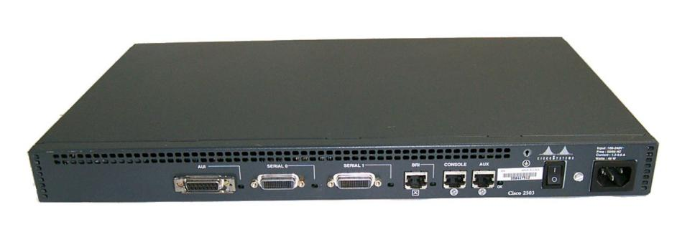

(Figure 4.1)

Modular Router :- easily adds/removes component. Ex: 2600 , 2800, 2900 Series

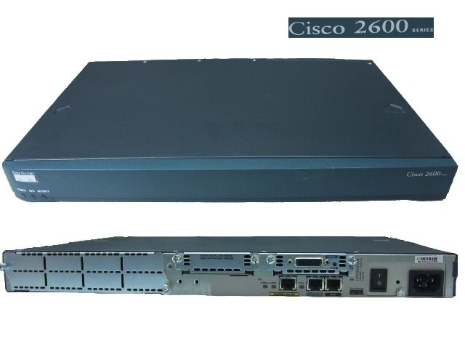

(Figure 4.2)

**4.4 Router Components.**

1. ROM : ROM stands for Read Only Memory. It stores the System Bootstrap. It also Performs POST meaning POWER ON SELF TEST which checks all the hardware components of routers , checks power supply and then starts bootstrap loader. It also contains ROMMON Mode.

Syntax: Router#show version.

1. FLASH : It stores the router inter connectivity operating system (IOS) image.

Syntax: Router#show flash

1. NVRAM : Non-volatile Ram. Similar to a Hard Disk Drive. It stores and saves start-up configuration file.

Syntax: Router#show start

1. RAM : Random Access Memory. It stores running-configuration and config register value (2101(rommon), 2102(normal ), 2142(troubleshooting )

Syntax: Router#show run

**4.5 External Connections**

* Configuration connections

-Console and AUX

* LAN connections

-FastEthernet (usually)

* WAN connections – often via WAN Interface Cards (WICs)
* Newer hardware is module
* Makes upgrading cheaper

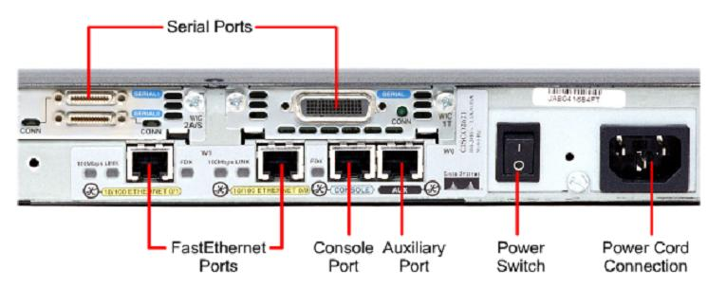

(Figure 4.3)-External Connections on a Router

**4.6 Router Connections**

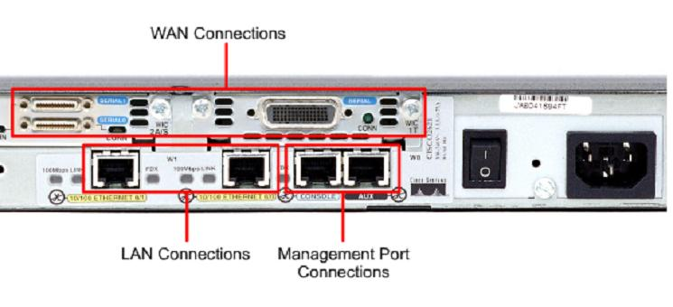

(Figure 4.4)-Router Connections

**Connecting to a Router**

* First-time connection must be via console cable attached to a PC
* PC runs terminal emulator e.g. Hyperterminal
* Correct parameters must be set

Routers are network layer equipment which forwards the incoming packets towards the required destination.

* Cisco 3600 Series
* Cisco 2600 Series
* Cisco 1700 Series
* Cisco 800 Series

**4.7 Cisco 3600 Series Router:**

The Cisco 3600 Series is a family of modular, multi-service access platforms for medium and large-sized offices and smaller Internet Service Providers. With over 70 modular interface options, the Cisco 3600 family provides solutions for data, voice, video, hybrid dial access, virtual networks (VPNs), and multi-protocol data routing. The high-performance, modular architecture protects customer’s investment in network technology and integrates the functions of several devices into a single, manageable solution. The Cisco 2600 and 3600 series of multi-service platforms has been greatly enhanced with many voice capabilities: added support for voice over Frame relay (VoFR) and Voice over.

ATM (VoATM-AALS) on the digital voice interfaces (TI and EI)

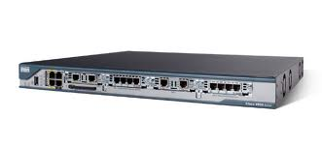

(Figure 4.5)- Cisco 3600 Router

From the beginning, the Cisco 3600 series was designed with performance, flexibility, and cost effectiveness in mind, making the multi-service branch office possible today.

**4.8 Router ports/interfaces.**

**S.NO PORT TYPE PURPOSE**

1. CONSOLE RJ-45 Used for router config.(PC)
2. AUX RJ-45 Used for modem(Internet)
3. E/FE/GE RJ-45 Used for LAN (Hub/Switch)
4. Serial 0/0 DB Used for WAN (Router,T1/E1)
5. VTY (0-15) LOGICAL Used for Telnet

Where E= Ethernet 10mbps

FE= Fast Ethernet 100mbps

GE= Giga Ethernet 1gbps

VTY= Virtual type

**4.9 Router Modes**

* ROUTER>: Router user mode. In this mode only basic commands can be used , ex. Ping, enable

Syntax: Router>enable(To enter privilege mode)

* ROUTER#: Router privilege mode. In this mode advanced commands can be used. Ex. ping, show, telnet, copy, delete, erase, config.

Syntax: Router#config terminal(To enter configure mode)

* ROUTER(CONFIG)#: Router configure mode. In this mode we configure the router ex. Hostname, banner, password, description, name resolution, DHCP, Backup & Restore configuration.

ROUTER(CONFIG)# router configuration mode further divided in 3 sub mode:

* LINE : In this mode we set console, aux, VTY password. Syntax: Router(config-line).
* INTERFACE : In this mode we configure Fast Ethernet, serial interface & set the IP address. Syntax:Router(config-if)
* ROUTING : In this mode we configure routing. Syntax: Router(config-router).

**4.10 Initial Configuration**

**4.10.1 Some Basic Commands:**

1. Show version: It shows OS file, processor, port, register value and interfaces.
2. Show clock: To show the time of the router.
3. Clock set: To set the time and data.
4. Show flash: It displays router IOS image.
5. Show run: It displays current configuration.
6. Show start: Shows saved data.
7. WR: Write memory, apply changes(Write mem).
8. Reload: Restart the router(If saved (wr) remains, or else deletes and restarts everything)
9. Delete<filename>: Delete file.
10. Erase: Erase folder or file system.
11. MKDIR: Creates folder.
12. DIR: Show folder.
13. No: Undo
14. PING<other machine IP address>: To ping other computers.
15. Disable/exit: Goes back to previous mode.
16. Enable: Goes from normal to privilege
17. Config: Goes from enable to config.
18. Ctrl+z/exit:{Disable doesn’t work in Router(config)#}

**4.10.2 Change the router name**

Router>

Router>enable

Router#

Router#config terminal

Router(config)#hostname Prab

Prab(config)#^z

Prab wr

**4.10.3 Set the router password (enable mode password)**

Prab>

Prab>enable

Prab#

Prab#config

Prab(config)#enable password ccna

Prab(config)#enable secret cisco

Prab(config)#^z

Prab(config)#wr

**Output:**

Password: ccna(hidden)

Password: cisco(hidden){Priority}

**4.10.4 Set the Console password**

Prab#config

Prab(config)#line console 0

Prab(config-line)#login

Prab(config-line)#password con

Prab(config-line)#^z

Prab#wr

Prab# exit

**Output:**

User access verification

Password: con (hidden)

**4.10.5 Set the VTY password(TELNET)**

Prab#config

Prab(config)#line vty 0 4

Prab(config-line)#login

Prab(config-line)#password vty

Prab(config-line)#^z

Prab#wr

**4.11 Interface Configuration**

Configure the interface Ethernet 0

Interface e 0

Configure the first Serial interface

Interface s 0

Configure the second Token ring interface

Interface t 1

Enable an interface

No shutdown

Disable an interface

Shutdown

Set the clock rate on a DCE (make a router a DCE)

Clock rate 56000

Set the bandwidth

Bandwidth 64

Display the status of an interface

Show interface serial 1

Display DTE/DCE state

Show controller serial 1

Set keepalive period

Keepalive 10

**4.12 IP Configuration**

Disable IP routing (IP routing is enabled by default)

No ip routing

Display IP routing table

Show ip route

Configure an interface with an IP address

Ip address 192.168.1.12 255.255.255.0

Enable RIP

Router rip

Network [network-address1]

Network [network-address2…]

Enable split Horizon on an interface

Ip split-horizonEnable RIP Triggered updates (only send updates when routing table has changed instead of every 30 seconds)

Ip rip triggered

Disable automatic route summarization

No auto-summary

Enable IGRP

Router igrp [as-number]

Network [network-address1]

Network [network-address2...]

**4.13 STARTING A ROUTER**

**W**hen a Cisco router is started for the first time, it does not have an initial configuration. The router prompts the user for a minimum of details. This basic setup is not intended for entering complex configurations or protocol features. The setup command gives you the following option:

* Go to the EXEC prompt without saving the created configuration.
* Go back to the beginning of setup without saving the created configuration.
* Accept the created configuration, save it to NRAM, and exit the EXEC mode.

Default answers appear in square brackets ([ ]). You can accept the defaults by pressing the Return key. At the first setup prompt, you can enter no to discontinue setup. You can abort the setup process at any time by pressing Ctrl+C.

Configuring the Router

ROM privileged EXEC mode, the configure terminal command provides access to global configuration mode. From global configuration mode. You can access specific configuration modes, such as the following:

Interface: Configures operations on a per-interface basis.

Sub-interface: Configures multiple virtual interfaces.

Controller: Support commands that configure controllers (such as E1 and T1)

Line: Configures the operation of a terminal line.

Router: Configures IP routing protocols.

**Assigning a Router Name Example**The hostname command can name a router:

>enable

#configure terminal

(config)#hostname Router

1. **Switching**

A network switch or switching hub is a computer networking device that connects network segments. The network switch plays an integral part in most modern Ethernet local area networks (LANs). Mid-to-large sized LANs contain a number of linked managed switches. Small office/home office (SOHO) applications typically use a single switch, or an all-purpose converged device such as a gateway to access small office/home broadband services such as DSL or cable internet

### **5.1 Configuration options**

* Unmanaged switches — These switches have no configuration interface or options. They are plug and play. They are typically the least expensive switches, found in home, SOHO, or small businesses. They can be desktop or rack mounted.
* Managed switches — These switches have one or more methods to modify the operation of the switch. Common management methods include: a command-line interface (CLI) accessed via serial console, telnet or Secure Shell, an embedded Simple Network Management Protocol (SNMP) agent allowing management from a remote console or management station, or a web interface for management from a web browser. Examples of configuration changes that one can do from a managed switch include: enable features such as Spanning Tree Protocol, set port bandwidth, create or modify Virtual LANs(VLANs), etc.

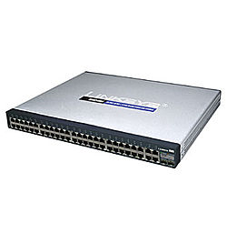

(Figure 5.1)-Linksys 48-port switch

Followings are some basic commands of Cisco Catalyst 1900 switch commands:

* **Show running-config:** This command displays the memory status of the Cisco Catalyst 1900 switch
* **Show interfaces:** This command displays the detailed information about all the interfaces of Cisco Catalyst 1900 switch.
* **Show interfaces** Ethernet **0/1:** This command displays the detailed information about a specific 10baseT Ethernet interface of the Cisco Catalyst 1900 switch
* **Show interfaces Fast Ethernet 0/26:** This command displays the detailed information about a specific 100baseT Fast Ethernet interface of the Cisco Catalyst 1900 switch
* **Show ip:** This command displays the ip configuration of the Cisco Catalyst 1900 switch
* **Show Mac-address-table:** This command displays the Mac addresses of the devices that are currently connected to the Cisco Catalyst 1900 switch.
* **Show Mac-address-table security:** This command displays the address table size and the addressing security of each interface of the Cisco Catalyst 1900 switch.
* **Show** VLAN**:** This command displays the status of current VLANs enabled on the Cisco Catalyst 1900 switch.
* **Show VLAN-membership:** This command displays the VLAN membership of all the ports on the Cisco Catalyst 1900 switch.
* **Show Spantree 1:** This command displays the complete information about the spanning tree protocol 1 that is by default enabled on the Cisco Catalyst 1900 switch.
* **Copy nvram tftp: //host/dst_file:** This command is used to send the configuration to a TFTP server.
* **Copy tftp: //host/src_file nvram:** This command is used to download the configuration from a TFTP server.
* **Delete nvram:** This command is used to reset the system configuration to factory defaults.

## **5.2 Show Cisco Switch Commands**

Here are some show commands of Cisco switches:

* **Show version:** This command displays the hardware and software status of the Cisco switch
* **Show flash:** This command displays the files and directories in the flash of the Cisco switch
* **Show interfaces:** This command displays the detailed information about all the interfaces of the Cisco switch
* **Show interfaces fast Ethernet 0/x:** This command displays the detailed information about the specific interface of the Cisco switch
* **Show interfaces VLAN 1:** This command displays the ip address configuration of VLAN 1
* **Show running-config:**This command displays the status of RAM
* **Show startup-config:**This command displays the status of NVRAM
* **Show-mac-address-table:** This command displays the MAC address of the devices that are directly connected with any port of the switch.
* **Show port-security:** [interface] [address]: This command displays the port security options on the interface
* **Show history:** This command displays the last ten commands that are executed in the switch configuration
* **Show line:** This command is used to view the brief information about all the lines of the Cisco switch
* **Show line console 0:** This command is used to view the detailed information about the specific line of the Cisco switch
* **Erase startup-config:** This command is used to erase the nvram of the Cisco switch

## **5.3 Cisco Switch Configuration Commands**

* **Configure terminal:** This command is used to enter in the global configuration mode of the Cisco switch
* **Hostname:** This command is used to assign the hostname of the Cisco switch
* **Enable password:** This command is used to set the enable password of the Cisco switch
* **Enable secret:** This command is used to set the encrypted password of the Cisco switch that is used for entering in the privileged mode
* **Interface VLAN 1:** This is a global configuration command used to configure the VLAN interface of the Cisco switch
* **Interface fast Ethernet 0/x:** This command is used to configure the specific interface of the Cisco switch
* **IP address:** This command is used to configure the ip address of any interface of the Cisco switch
* **IP default-gateway:** This is an interface configuration command to set the default gateway
* **Speed:** This command is used to set the speed for the interface of the Cisco switch
* **Duplex:** This command is used to set the duplex setting for the interface of the Cisco switch
* **Line console 0:** This command is used to enter in the specific line configuration mode of the Cisco switch
* **Password:** This command is used to set the password of any line of the Cisco switch

1. **Requirements for Project**

The Banks & ATM has provided a partially completed logical diagram of the required network.

The company has also provided networking equipment for development and demonstration.

* The company consists of 3 remote locations. One being the main building and other two locations on a remote site.
* The main building consists of 6 departments with the following requirement:

|  |  |  |
| --- | --- | --- |
| **Department** | **Number** | **Remarks** |
| BANKS | 120 | Size can vary up to 255 |
| ATM | 120 | Size can vary up to 255 |
| CONTYROL | 120 | Size can vary up to 255 |

* 8 servers that distributed in all locations
* The following ip address to be used for connection with SERVER
* 198.168.0.1
* 198.168.0.2
* 198.168.0.3
* 198.168.0.4
* 198.168.0.5
* 198.168.0.6
* 198.168.0.7
* 198.163.0.1
* 198.163.0.2
* 198.163.0.3
* 198.163.0.4
* 198.163.0.5
* 198.163.0.6
* 198.163.0.7
* Following address are used for internal addressing.
* 10.0.0.0
* 20.0.0.0
* 30.0.0.0
* 40.0.0.0
* 11.0.0.0
* 21.0.0.0
* 31.0.0.0
* 41.0.0.0
* Use VLSM for IP addressing.
* Device details

|  |  |  |
| --- | --- | --- |
| **DEVICE** | **MODEL** | **NUMBER** |
| Router | 2811 | 4 |
| Switches | 2960 | 10 |
| Server | - | 11 |

1. **IP Addressing**

An IP (Internet Protocol) address is a unique identifier for a node or host connection on an IP network. An IP address is a 32 bit binary number usually represented as 4 decimal values, each representing 8 bits, in the range 0 to 255 (known as octets) separated by decimal points. This is known as "dotted decimal" notation.

**7.1 Address Classes**

There are 5 different address classes. You can determine which class any IP address is in by examining the first 4 bits of the IP address.

· **Class A** addresses begin with **0xxx**, or **1 to 126** decimal.

· **Class B** addresses begin with **10xx**, or **128 to 191** decimal.

· **Class C** addresses begin with **110x**, or **192 to 223** decimal.

· **Class D** addresses begin with **1110**, or **224 to 239** decimal.

· **Class E** addresses begin with **1111**, or **240 to 254** decimal.

Addresses beginning with **01111111**, or **127** decimal, are reserved for loopback and for internal testing on a local machine Class D addresses are reserved for multicasting. Class E addresses are reserved for future use.

**7.2 Subnetting**

Subnetting an IP Network can be done for a variety of reasons, including organization, use of different physical media (such as Ethernet, FDDI, WAN, etc.), preservation of address space, and security. The most common reason is to control network traffic. In an Ethernet network, all nodes on a segment see all the packets transmitted by all the other nodes on that segment. Performance can be adversely affected under heavy traffic loads, due to collisions and the resulting retransmissions. A router is used to connect IP networks to minimize the amount of traffic each segment must receive.

**7.3 Subnet Masking**

Applying a subnet mask to an IP address allows you to identify the network and node parts of the address. Performing a bitwise logical AND operation between the IP address and the subnet mask results in the *Network Address* or Number.

**7.4 DHCP**

The Dynamic Host Configuration Protocol (DHCP) is an Internet protocol for automating the configuration of computers that use TCP/IP. DHCP can be used to automatically assign IP addresses, to deliver TCP/IP stack configuration parameters such as the subnet mask and default router, and to provide other configuration information such as the addresses for printer, time and date.

1. **Routing Protocol**

Routing is the act of moving information across an inter-network from a source to a destination. Routing involves two basic activities: determining optimal routing paths and transporting information groups (typically called packets) through an inter-network.

Routing protocols use metrics to evaluate what path will be the best for a packet to travel. A metric is a standard of measurement, such as path bandwidth, that is used by routing algorithms to determine the optimal path to a destination. To aid the process of path determination, routing algorithms initialize and maintain routing tables, which contain route information. Route information varies depending on the routing algorithm used.

Routing algorithms fill routing tables with a variety of information. Destination/next hop associations tell a router that a particular destination can be reached optimally by sending the packet to a particular router representing the "next hop" on the way to the final destination. When a router receives an incoming packet, it checks the destination address and attempts to associate this address with a next hop.

Routing algorithms often have one or more of the following design goals:

•http://www.cisco.com/en/US/i/templates/blank.gifOptimality

•http://www.cisco.com/en/US/i/templates/blank.gifSimplicity and low overhead

•http://www.cisco.com/en/US/i/templates/blank.gifRobustness and stability

•http://www.cisco.com/en/US/i/templates/blank.gifRapid convergence

•http://www.cisco.com/en/US/i/templates/blank.gifFlexibility

**8.1 Types of routing :**

**8.1.1 STATIC ROUTING ALGORITHMS**

These are hardly algorithms at all, but are table mappings established by the network administrator before the beginning of routing. These mappings do not change unless

the network administrator alters them. Algorithms that use static routes are simple to design and work well in environments where network traffic is relatively predictable and where network design is relatively simple.

**8.1.2 DYNAMIC ROUTING ALGORITHMS**

These are which adjust to changing network circumstances by analyzing incoming routing update messages. If the message indicates that a network change has occurred, the routing software recalculates routes and sends out new routing update messages. These messages permeate the network, stimulating routers to rerun their algorithms and change their routing tables accordingly.

The various routing protocol that can be used are:

1. **RIP** (routing information protocol) is a distance vector routing protocol. It sends complete routing table out to all other members in an interval of 30 seconds. It uses hop count as a metric and by default hop count is set to 15.
2. **IGRP** is a distance vector Interior Gateway Protocol (IGP). IGRP uses a composite metric that is calculated by factoring weighted mathematical values for internetwork delay, bandwidth, reliability, and load. Network administrators can set the weighting factors for each of these metrics, although great care should be taken before any default values are manipulated.
3. **EIGRP** Key capabilities that distinguish EIGRP from other routing protocols include fast convergence, support for variable-length subnet mask, support for partial updates, and support for multiple network layer protocols.

A router running EIGRP stores all its neighbors' routing tables so that it can quickly adapt to alternate routes. If no appropriate route exists, EIGRP queries its neighbors to discover an alternate route.

EIGRP does not make periodic updates. Instead, it sends partial updates only when the metric for a route changes.

1. **OSPF** is a link-state routing protocol that calls for the sending of link-state advertisements (LSAs) to all other routers within the same hierarchical area. Information on attached interfaces, metrics used, and other variables is included in OSPF LSAs. As OSPF routers accumulate link-state information, they use the SPF algorithm to calculate the shortest path to each node.

|  |  |  |  |  |  |  |  |
| --- | --- | --- | --- | --- | --- | --- | --- |
| Routing **Protocol** | **Property 1**  **Supports VLSM** | **Property 2**  **Scalable** | **Property 3**  **Uses multicast updates** | **Property 4**  **Has view of complete toplology** | **Property 5**  **Easy to configure** | **Property 6**  **Proprietary** | **Total** |
| RIP V1 | - | - | - | - | - | - | 2 |
| RIP v2 | - | - | - | - | - | - | 4 |
| IGRP | - | - | - | - | - | - | 2 |
| EIGRP | - | - | - | - | - | - | 3 |
| OSPF | + | + | + | + | - | + | 5 |

1. **VLAN**

VLAN is a switched network that is logically segmented by functions, project teams, or applications

without regard to the physical location of users. For example, several end stations might be grouped as a department, such as engineering or accounting. When the end stations are physically located close to one another, you can group them into a LAN segment. If any of the end stations are in different buildings (not the same physical LAN segment), you can then group them into a VLAN.

You can assign each switch port to a VLAN. Ports in a VLAN share broadcast traffic. Ports that do not belong to that VLAN do not share the broadcast traffic.

VLANs provide the following features:

**9.1http://www.cisco.com/en/US/i/templates/blank.gifSimplification of end-station moves, adds, and changes**

When an end station is physically moved to a new location, its attributes can be reassigned from a network management station through Simple Network Management Protocol (SNMP) or through the user interface menus. When an end station is moved within the same VLAN, it retains its previously assigned attributes in its new location. When an end station is moved to a different VLAN, the attributes of the new VLAN are applied to the end station.

**9.2http://www.cisco.com/en/US/i/templates/blank.gifControlled traffic activity**

VLANs allow ports on the same or different switches to be grouped so that traffic is confined to members of only that group. This feature restricts broadcast, unicast, and multicast traffic (flooding) only to ports included in a certain VLAN. The management domain is a group of VLANs that are managed by a single administrative authority.

**9.3 Workgroup and network security**

You can increase security by segmenting the network into distinct broadcast domains. To this end, VLANs can restrict the number of users in a broadcast domain. You can

also control the size and composition of the broadcast domain by controlling the size and composition of a VLAN.

1. **Network Address Translation (NAT)**

NAT allows an [Internet Protocol (IP)](http://compnetworking.about.com/library/glossary/bldef-ip.htm) network to maintain public [IP addresses](http://compnetworking.about.com/library/glossary/bldef-ip.htm) separately from private IP addresses. NAT is a popular technology for Internet connection sharing. It is also sometimes used in server load balancing applications on corporate networks.

In it's most common configuration, NAT maps all of the private IP addresses on a home network to the single IP address supplied by an [Internet Service Provider (ISP)](http://compnetworking.about.com/library/glossary/bldef-isp.htm). This allows computers on the home [LAN](http://compnetworking.about.com/cs/lanvlanwan/g/bldef_lan.htm) to share a single Internet connection. Additionally, it enhances home network security by limiting the access of external computers into the home IP network space.

NAT works by snooping both incoming and outgoing IP datagrams. As needed, it modifies the source or destination address in the IP header (and the affected checksums) to reflect the configured address mapping. NAT technically supports either fixed or dynamic mappings of one or more internal and external IP addresses.

Network Address Translation allows a single device, such as a router, to act as agent between the Internet (or "public network") and a local (or "private") network. This means that only a single unique IP address is required to represent an entire group of computers to anything outside their network.

The shortage of IP addresses is only one reason to use NAT. Two other good reasons are:

* Security
* Administration

1. **Appendix I**

**Code:**

**North BANKING:-**

Rou Router#sh run

Building configuration...

**Current configuration : 1317 bytes**

**version 12.4**

no service timestamps log datetime msec

no service timestamps debug datetime msec

no service password-encryption

interface FastEthernet0/0

ip address 198.168.0.1 255.255.255.224

duplex au

to

speed auto

interface FastEthernet0/1

no ip address

duplex auto

speed auto

shutdown

interface Serial0/0/0

no ip address

shutdown

interface Serial0/0/1

no ip address

shutdown

interface Serial0/1/0

bandwidth 325435

ip address 192.168.0.9 255.255.255.252

clock rate 64000

interface Serial0/1/1

bandwidth 325435

ip address 192.168.0.13 255.255.255.252

clock rate 64000

interface Serial0/2/0

no ip address

shutdown

interface Serial0/2/1

no ip address

shutdown

interface Serial0/3/0

bandwidth 4545

ip address 192.168.0.1 255.255.255.252

clock rate 64000

!

interface Serial0/3/1

bandwidth 4545

ip address 192.168.0.5 255.255.255.252

clock rate 64000

!

interface Vlan1

no ip address

shutdown

router ospf 100

log-adjacency-changes

network 192.168.0.0 0.0.0.3 area 0

network 192.168.0.4 0.0.0.3 area 0

network 192.168.0.8 0.0.0.3 area 0

network 192.168.0.12 0.0.0.3 area 0

network 198.168.0.0 0.0.0.3 area 0

network 198.168.0.0 0.0.0.31 area 0

ip classless

line con 0

line vty 0 4

login

end

ters

**PNB SERVER:-**

Router#SH run

Building configuration...

Current configuration : 894 bytes

version 12.2

no service timestamps log datetime msec

no service timestamps debug datetime msec

no service password-encryption

hostname Router

interface FastEthernet0/0

no ip address

duplex auto

speed auto

shutdown

interface FastEthernet0/1

no ip address

duplex auto

speed auto

shutdown

interface Serial0/0

ip address 193.168.0.5 255.255.255.252

clock rate 64000

interface Serial0/1

ip address 193.168.0.9 255.255.255.252

clock rate 64000

interface Serial0/2

ip address 192.168.0.2 255.255.255.252

interface Serial0/3

ip address 193.168.0.1 255.255.255.252

clock rate 64000

router ospf 100

log-adjacency-changes

network 192.168.0.0 0.0.0.3 area 0

network 193.168.0.0 0.0.0.3 area 0

network 193.168.0.4 0.0.0.3 area 0

network 193.168.0.8 0.0.0.3 area 0

ip classless

line con 0

line vty 0 4

login

end

**SBI SERVER:-**

Router#Sh run

Building configuration...

Current configuration : 1116 bytes

version 12.2

no service timestamps log datetime msec

no service timestamps debug datetime msec

no service password-encryption

hostname Router

ip dhcp excluded-address 20.0.0.1

ip dhcp pool abc2

network 20.0.0.0 255.255.255.224

default-router 20.0.0.1

dns-server 198.168.0.6

interface FastEthernet0/0

ip address 20.0.0.1 255.255.255.224

ip nat inside

duplex auto

speed auto

interface FastEthernet0/1

no ip address

duplex auto

speed auto

shutdown

interface Serial0/0

no ip address

shutdown

interface Serial0/1

no ip address

shutdown

interface Serial0/2

ip address 193.168.0.14 255.255.255.252

ip nat outside

interface Serial0/3

no ip address

shutdown

router ospf 100

log-adjacency-changes

network 20.0.0.0 0.0.0.31 area 0

network 193.168.0.12 0.0.0.3 area 0

ip nat pool contorl 193.168.0.13 193.168.0.14 netmask 255.255.255.252

ip nat inside source list 1 pool contorl

ip classless

access-list 1 permit 20.0.0.0 0.0.0.31

access-list 10 deny any

access-list 10 permit 20.0.0.32 0.0.0.31

line con 0

line vty 0 4

login

end

**HDFC ROUTER:-**

Router#sh run

Building configuration...

Current configuration : 929 bytes

version 12.2

no service timestamps log datetime msec

no service timestamps debug datetime msec

no service password-encryption

hostname Router

interface FastEthernet0/0

no ip address

duplex auto

speed auto

shutdown

interface FastEthernet0/1

no ip address

duplex auto

speed auto

shutdown

interface Serial0/0

bandwidth 67767

ip address 194.168.0.5 255.255.255.252

clock rate 64000

interface Serial0/1

bandwidth 78989

ip address 194.168.0.9 255.255.255.252

clock rate 64000

interface Serial0/2

ip address 192.168.0.10 255.255.255.252

interface Serial0/3

ip address 194.168.0.1 255.255.255.252

clock rate 64000

router ospf 100

log-adjacency-changes

network 192.168.0.8 0.0.0.3 area 0

network 194.168.0.0 0.0.0.3 area 0

network 194.168.0.4 0.0.0.3 area 0

network 194.168.0.8 0.0.0.3 area 0

ip classless

line con 0

line vty 0 4

login

end

**ICICI ROUTER:-**

Router#SH RUN

Building configuration...

Current configuration : 920 bytes

version 12.2

no service timestamps log datetime msec

no service timestamps debug datetime msec

no service password-encryption

hostname Router

interface FastEthernet0/0

no ip address

duplex auto

speed auto

shutdown

interface FastEthernet0/1

no ip address

duplex auto

speed auto

shutdown

interface Serial0/0

ip address 194.168.0.21 255.255.255.252

clock rate 64000

interface Serial0/1

ip address 192.168.0.14 255.255.255.252

interface Serial0/2

ip address 194.168.0.13 255.255.255.252

clock rate 64000

interface Serial0/3

bandwidth 234445

ip address 194.168.0.17 255.255.255.252

clock rate 64000

router ospf 100

log-adjacency-changes

network 192.168.0.12 0.0.0.3 area 0

network 194.168.0.12 0.0.0.3 area 0

network 194.168.0.16 0.0.0.3 area 0

network 194.168.0.20 0.0.0.3 area 0

ip classles

line con 0

line vty 0 4

login

end

**SOUTH SERVER:-**

SOUTHBANK#SH RUN

Building configuration...

Current configuration : 1266 bytes

version 12.4

no service timestamps log datetime msec

no service timestamps debug datetime msec

no service password-encryption

hostname SOUTHBANK

interface FastEthernet0/0

ip address 198.163.0.1 255.255.255.224

duplex auto

speed auto

interface FastEthernet0/1

no ip address

duplex auto

speed auto

shutdown

interface Serial0/0/0

ip address 192.163.0.13 255.255.255.252

clock rate 64000

interface Serial0/0/1

bandwidth 6743876

ip address 192.163.0.9 255.255.255.252

clock rate 64000

interface Serial0/1/0

bandwidth 345356

ip address 192.163.0.1 255.255.255.252

clock rate 64000

interface Serial0/1/1

ip address 192.163.0.5 255.255.255.252

clock rate 64000

interface Serial0/2/0

no ip address

shutdown

!

interface Serial0/2/1

no ip address

shutdown

interface Serial0/3/0

no ip address

shutdown

interface Serial0/3/1

no ip address

shutdown

interface Vlan1

no ip address

shutdown

router ospf 100

log-adjacency-changes

network 192.163.0.0 0.0.0.3 area 0

network 192.163.0.4 0.0.0.3 area 0

network 192.163.0.8 0.0.0.3 area 0

network 192.163.0.12 0.0.0.3 area 0

network 198.163.0.0 0.0.0.31 area 0

ip classless

no cdp run

line con 0

line vty 0 4

login

end

**PNB SERVER :-**

Router#sh run

Building configuration...

Current configuration : 993 bytes

version 12.2

no service timestamps log datetime msec

no service timestamps debug datetime msec

no service password-encryption

hostname Router

interface FastEthernet0/0

no ip address

duplex auto

speed auto

shutdown

interface FastEthernet0/1

no ip address

duplex auto

speed auto

shutdown

interface Serial0/0

bandwidth 4534

ip address 122.168.0.5 255.255.255.252

clock rate 64000

interface Serial0/1

bandwidth 7674

ip address 122.168.0.9 255.255.255.252

clock rate 64000

interface Serial0/2

ip address 192.163.0.2 255.255.255.252

interface Serial0/3

bandwidth 766734

ip address 122.168.0.1 255.255.255.252

clock rate 64000

router ospf 100

log-adjacency-changes

network 122.168.0.0 0.0.0.3 area 0

network 122.168.0.4 0.0.0.3 area 0

network 122.168.0.8 0.0.0.3 area 0

network 192.163.0.0 0.0.0.3 area 0

network 12.168.0.12 0.0.0.3 area 0

ip classless

no cdp run

line con 0

line vty 0 4

login

end

**SBI SERVER:-**

SBIBANK#sh run

Building configuration...

Current configuration : 950 bytes

version 12.2

no service timestamps log datetime msec

no service timestamps debug datetime msec

no service password-encryption

hostname SBIBANK

interface FastEthernet0/0

no ip address

duplex auto

speed auto

shutdown

interface FastEthernet0/1

no ip address

duplex auto

speed auto

shutdown

interface Serial0/0

bandwidth 43545

ip address 122.168.0.17 255.255.255.252

clock rate 64000

interface Serial0/1

bandwidth 3454546

ip address 122.168.0.21 255.255.255.252

clock rate 64000

interface Serial0/2

ip address 192.163.0.6 255.255.255.252

interface Serial0/3

ip address 122.168.0.13 255.255.255.252

clock rate 64000

router ospf 100

log-adjacency-changes

network 122.168.0.12 0.0.0.3 area 0

network 122.168.0.16 0.0.0.3 area 0

network 122.168.0.20 0.0.0.3 area 0

network 192.163.0.4 0.0.0.3 area 0

ip classless

no cdp run

line con 0

line vty 0 4

login

end

**HDFC SERVER:-**

HDFCBANK#sh run

Building configuration...

Current configuration : 966 bytes

version 12.2

no service timestamps log datetime msec

no service timestamps debug datetime msec

no service password-encryption

hostname HDFCBANK

interface FastEthernet0/0

no ip address

duplex auto

speed auto

shutdown

interface FastEthernet0/1

no ip address

duplex auto

speed auto

shutdown

interface Serial0/0

bandwidth 354435

ip address 122.122.0.1 255.255.255.252

clock rate 64000

interface Serial0/1

bandwidth 78433

ip address 122.122.0.5 255.255.255.252

clock rate 64000

interface Serial0/2

bandwidth 34566

ip address 192.163.0.10 255.255.255.252

interface Serial0/3

bandwidth 35455

ip address 122.122.0.9 255.255.255.252

clock rate 64000

router ospf 100

log-adjacency-changes

network 122.122.0.0 0.0.0.3 area 0

network 122.122.0.4 0.0.0.3 area 0

network 122.122.0.8 0.0.0.3 area 0

network 192.163.0.8 0.0.0.3 area 0

ip classless

line con 0

line vty 0 4

login

end

**ICICI SERVER:-**

ICICIBANK#SH RUN

Building configuration...

Current configuration : 954 bytes

version 12.2

no service timestamps log datetime msec

no service timestamps debug datetime msec

no service password-encryption

hostname ICICIBANK

interface FastEthernet0/0

no ip address

duplex auto

speed auto

shutdown

!

interface FastEthernet0/1

no ip address

duplex auto

speed auto

shutdown

!

interface Serial0/0

ip address 122.122.0.13 255.255.255.252

clock rate 64000

interface Serial0/1

bandwidth 22345

ip address 122.122.0.17 255.255.255.252

clock rate 64000

interface Serial0/2

ip address 192.163.0.14 255.255.255.252

interface Serial0/3

bandwidth 6568778

ip address 122.122.0.21 255.255.255.252

clock rate 64000

router ospf 100

log-adjacency-changes

network 122.122.0.12 0.0.0.3 area 0

network 122.122.0.16 0.0.0.3 area 0

network 122.122.0.20 0.0.0.3 area 0

network 192.163.0.12 0.0.0.3 area 0

ip classlesS

no cdp

line con 0

line vty 0 4

login

end

1. **Appendix II**

**Result:**

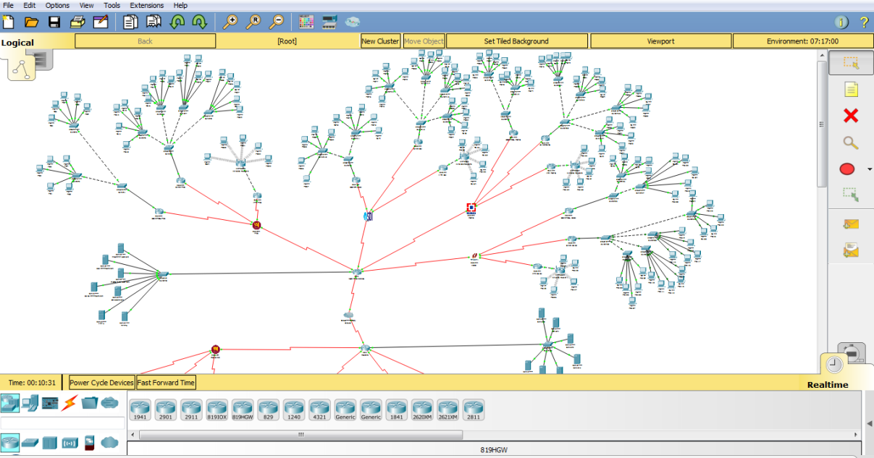

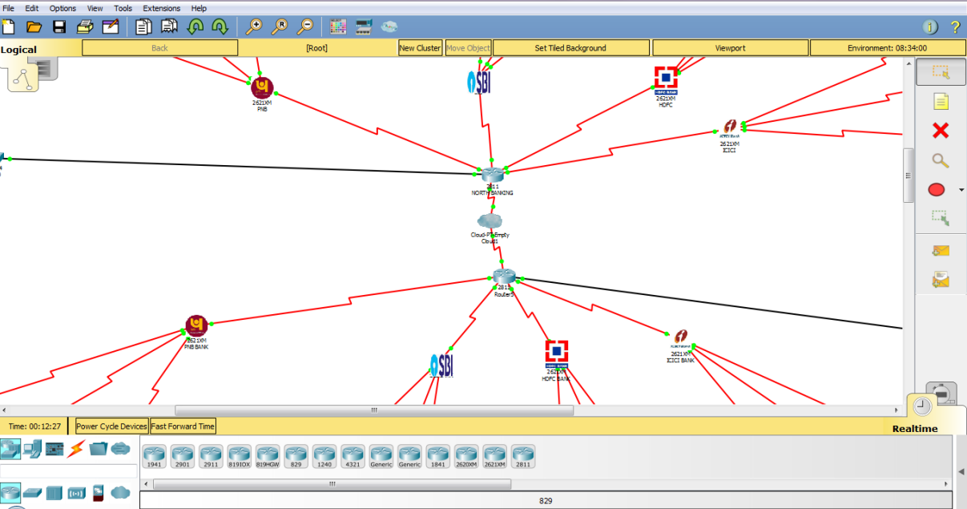

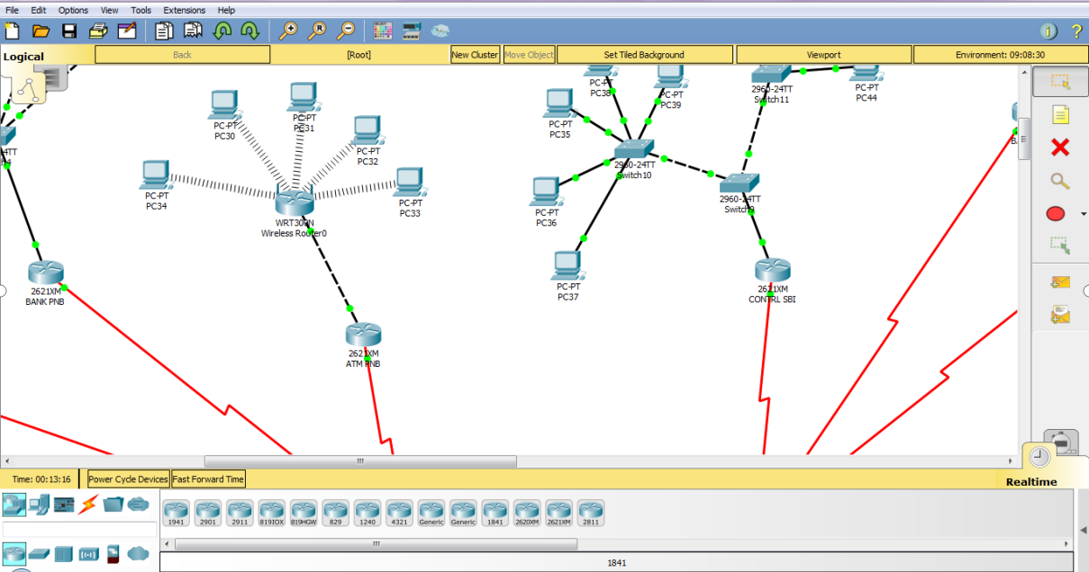

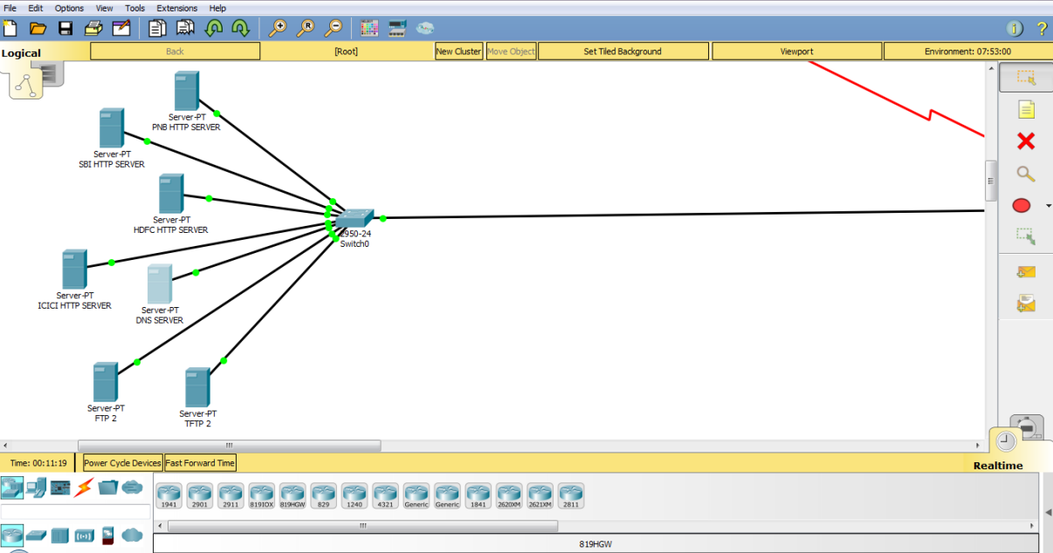

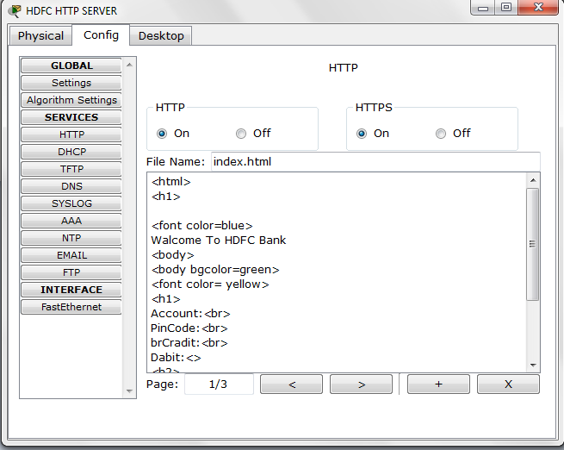

(Figure- HTTP Server)

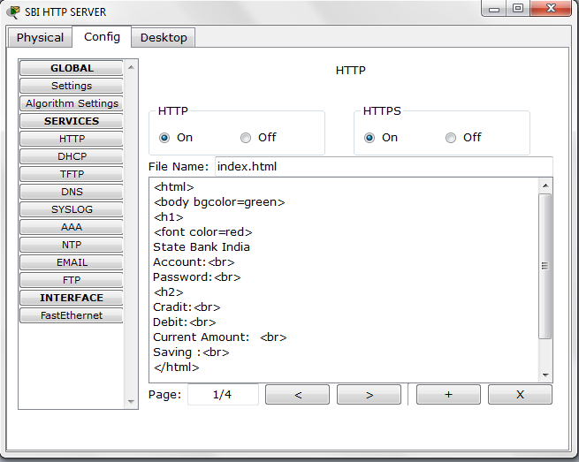

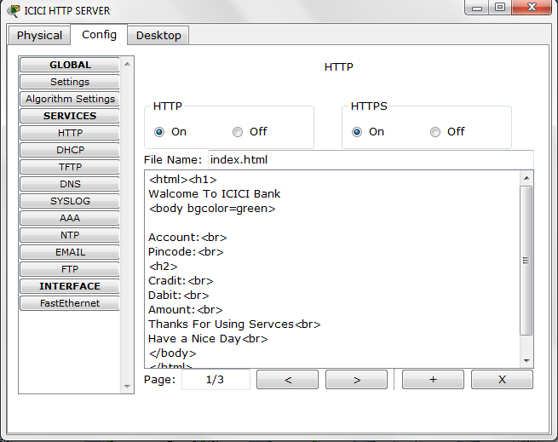

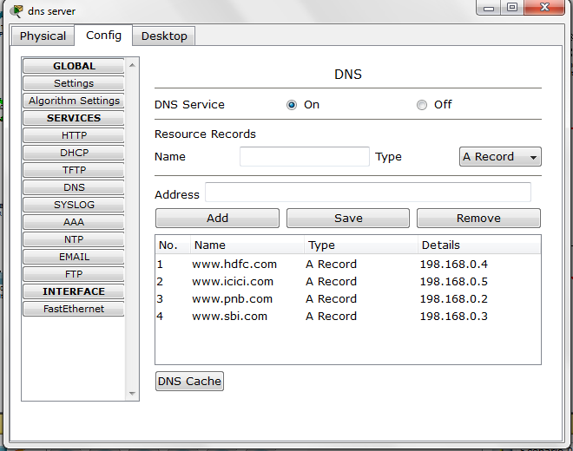

(Figure: DNS Server)

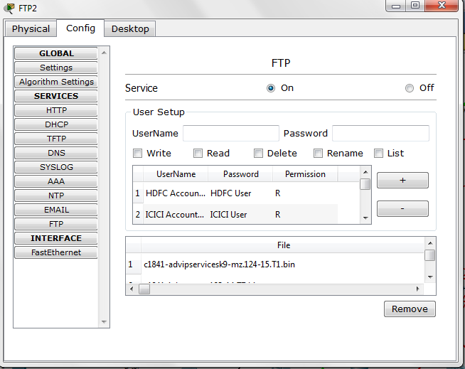

(Figure:FTP)

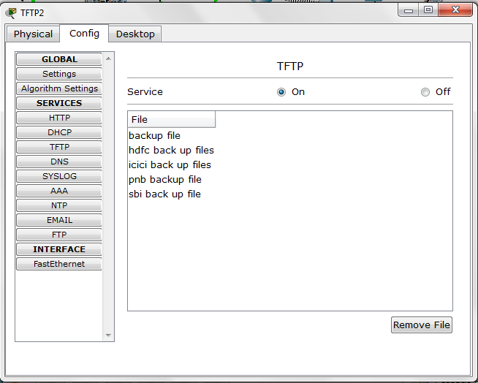

(Figure: TFTP)

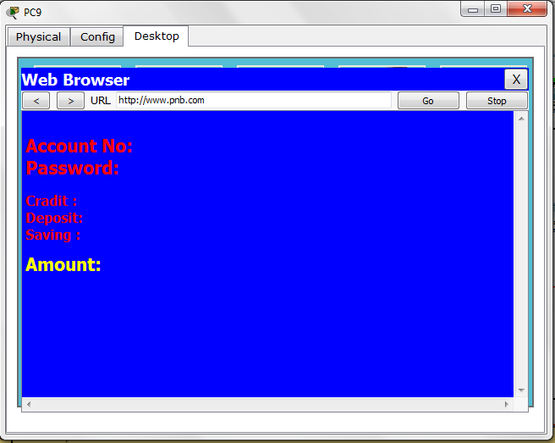

(Figure: Web browsing)

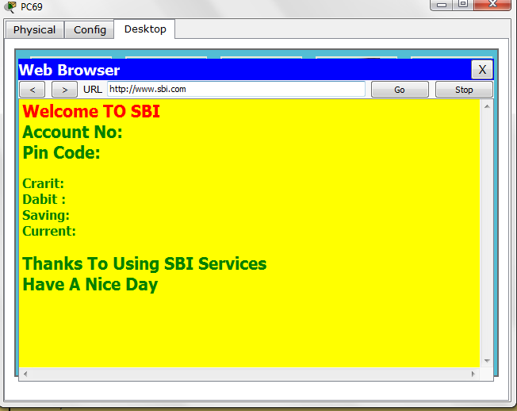

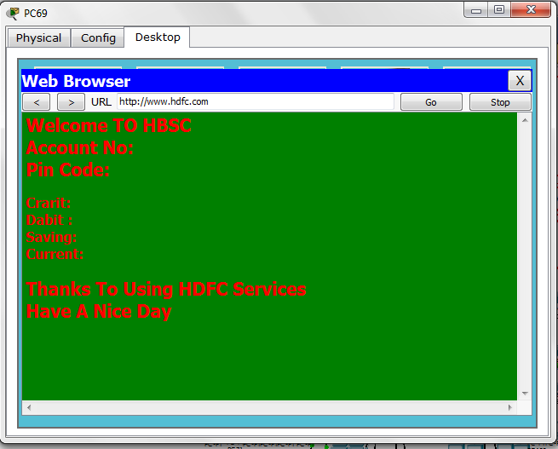

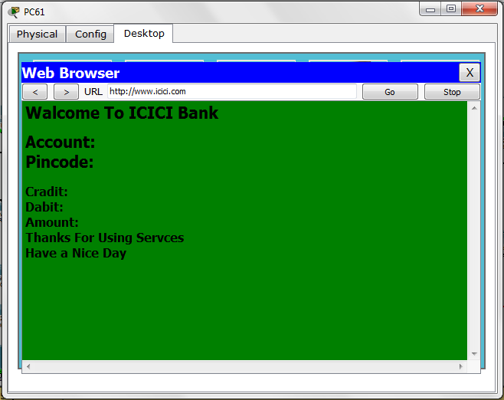

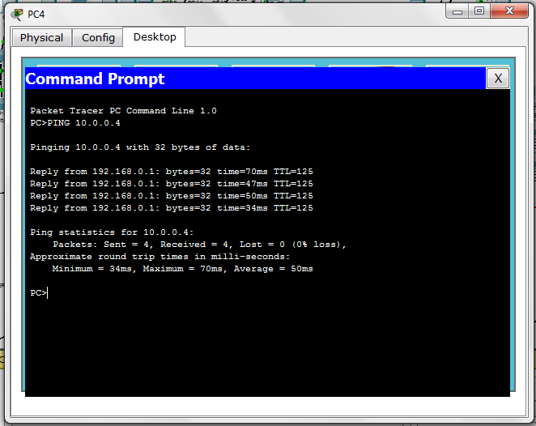

(Figure: Communications between two PCs and NAT translation)

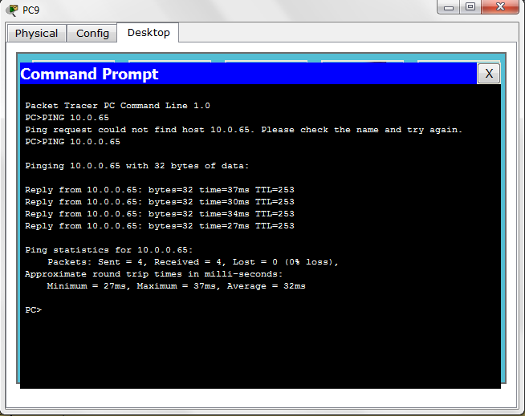

(Figure: Ping to PC without NAT)

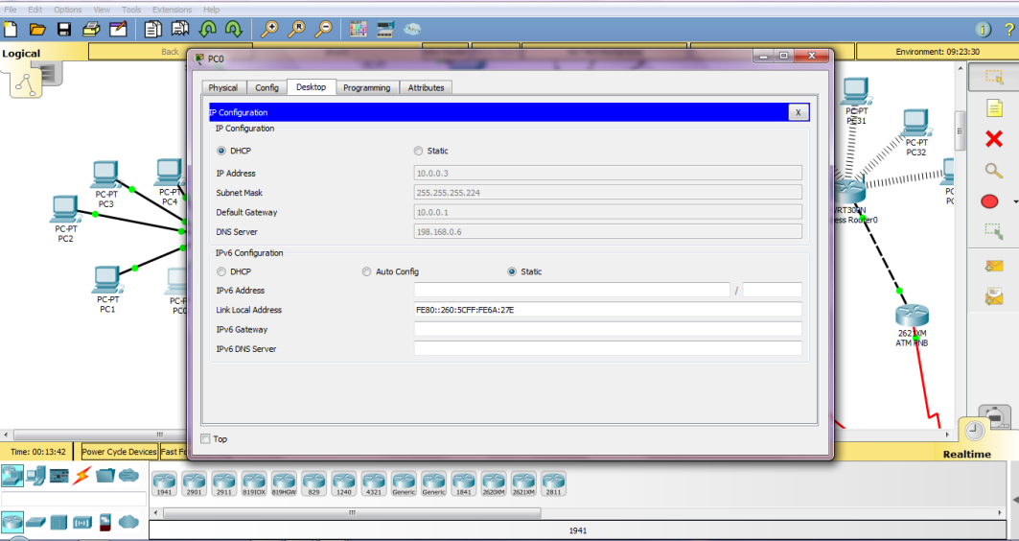

(Figure: DHCP IP address)

1. **Conclusion**

Nowadays, technological development and automated system development is a more essential and crying need for the expansion of banking services because they will need fewer employees by using an automated system. On top of that security is a major issue regarding banking issues. With this system, the network will be more easy to handle and it will route the data in the shortest path in a vast distributed system.

This system aims to overcome the lacking of the manual system. All branches of the Bank situated at District level provide the Banking services to customers and had to send report to the central branch manually,which sometimes create problem to get up-to-date information rapidly. But now through this system whenever any transaction will be taking place it will store in the central database and authorized person can get necessary information or report when they get into the system from any branches through Wide Area Network (WAN).

1. **Future Scope**

The trend of growth of Online Banking brings many security issues and increasing costs of implementing a higher security system for both Online Banking users and banks. Security is all about risks and associated costs in his paper.The most critical issue of Online Banking security is to protect valuable information that is susceptible to unauthorized access by attackers. Hence, banks must constantly increase security. At the same time, the banks must manage costs to make a profit. In contrast, increasing security is increasing the cost for attackers to break into the system, and increasing the punishment that the attackers may suffer. Hence the Internet criminals/attackers/crackers may lose motivation for hacking a high-security online banking system.

In the future of networking, engineers will have to design networks that adhere to applications. An application can bring about a change that could result in the data traffic being handled better than being limited to monolithic infrastructures. Network admins about 5 to 10 years later will be closer to developers.

1. **References**

* <https://www.computerhope.com/jargon/n/network.htm>
* <https://www.belden.com/blog/smart-building/network-types>
* <https://www.webopedia.com/TERM/H/hub.html>
* <https://www.includehelp.com/computer-networks/hubs-their-types-and-working.aspx>
* <https://www.computerhope.com/jargon/r/router.htm>
* <https://extr3metech.wordpress.com/2012/10/12/understanding-components-of-a-cisco-router/>
* <https://www.cisco.com/web/ANZ/cpp/refguide/hview/router/3600.html>
* <https://www.geeksforgeeks.org/cisco-router-modes/>
* <https://www.cisco.com/c/en/us/td/docs/routers/access/800M/software/800MSCG/routconf.html>
* <https://www.cisco.com/c/en_in/products/switches/index.html>
* <http://ecomputernotes.com/computernetworkingnotes/computer-network/what-is-switching>
* <https://www.cisco.com/c/en/us/td/docs/routers/nfvis/switch_command/b-nfvis-switch-command-reference/switch_show_commands.html>
* <http://www.ciscopress.com/articles/article.asp?p=2181836&seqNum=4>
* <https://www.cisco.com/c/en/us/support/docs/ip/routing-information-protocol-rip/13788-3.html>
* <https://www.computerhope.com/jargon/i/ip.htm>
* <https://www.iplocation.net/subnet-mask>
* <https://www.infoblox.com/glossary/dhcp-server/>
* <https://study-ccna.com/configure-cisco-router-as-dhcp-server/>
* <https://www.geeksforgeeks.org/classes-of-routing-protocols/>
* <https://www.geeksforgeeks.org/difference-between-static-and-dynamic-routing/>
* <https://en.wikipedia.org/wiki/Virtual_LAN>

<https://www.geeksforgeeks.org/network-address-translation-nat/>